- JDK 17 was used for this JavaCodeChunker project

- Run the following command to build the project
mvn clean package -DskipTests=true
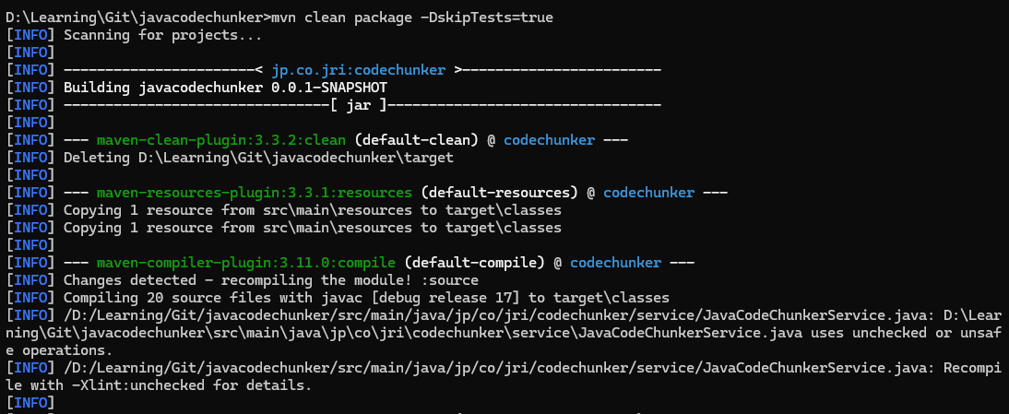

- Run the following command to generate the class level analysis
java -jar ./target/codechunker-0.0.1-SNAPSHOT.jar --project=D:\Learning\Git\sftp\src\main\java --per-class --output=D:\Learning\Git\sftp\output

Note:
-jar {path to the jar built from step 2}
--project {path to the src\main\java folder of the Java maven project to be analyzed}
--output {output folder for analysis results}
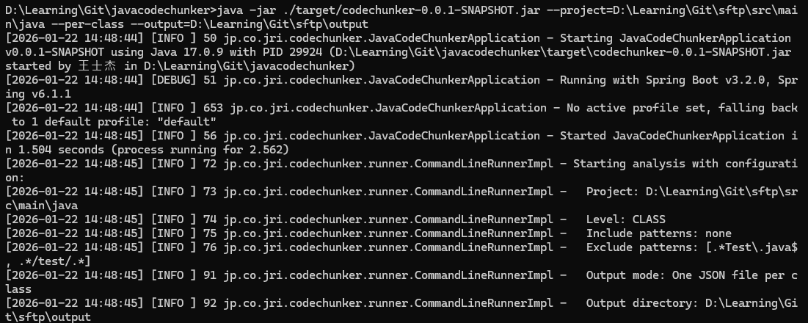

- Run the following command to generate the method level analysis
java -jar ./target/codechunker-0.0.1-SNAPSHOT.jar --project=D:\Learning\Git\sftp\src\main\java --per-class --method --output=D:\Learning\Git\sftp\output

Note:
--method {flag indicates that it is for method level analysis}
Rest of the parameters are the same as those used for class level analysis
